**Overview**

Box for Office 2016 is a plug-in for Microsoft Office 2016 that merges the convenience of your Box account with the productivity of Microsoft Office. This plug-in allows Microsoft Office 2016 to manage files from your Box account in the same way you would if they were on your hard drive. You can open files straight from your Box account into Office for editing, save a file from Office directly to your Box account, or even attach files from your Box to an email in Outlook. This eliminates the step of having to separately download files and manage them between software.

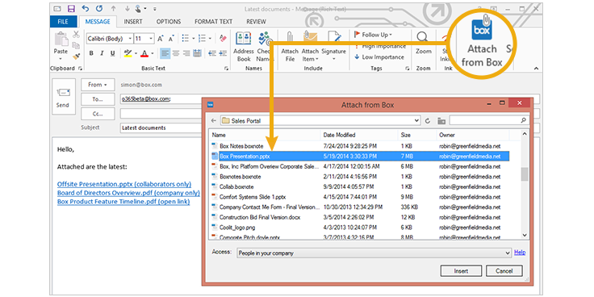

This plug-in can be used to attach a file from your Box account directly to your email in Microsoft Outlook.

**Set-Up and Configuration**

Box for Office can be downloaded from the Box website: <https://app.box.com/services/browse/search/box_for_office>

After downloading, install Box for Office 2016 by:

* 1. Closing any open Office applications, including Outlook.
  2. Start the install.

1. Click on **Get Started**.
2. Click **Next** to complete the install.

After Box for Office 2016 has been installed, open *any* Office application and click on **File**, then **Open**. Click the “Box” tab on the left (highlighted in blue), then click the "Sign-In" icon (circled in gold, which will connect all your Office programs to your Box account, and you'll be able to use any files there as needed going forward.

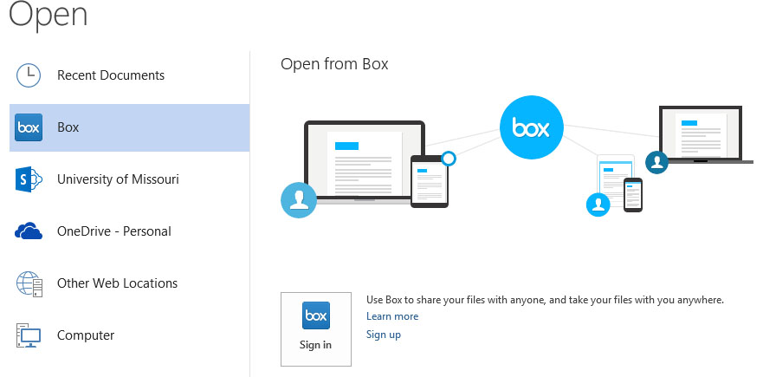

You will need to sign in to your Box account when you first install the plug-in, shown here. Afterward, this “Box” tab can be used to manage files between your Box and Office.

**FAQs**

* **Which platforms is Box for Office available on?**

Box for Office is a plug-in available only for PCs, for use with Microsoft Office 2016.

* **What file types are compatible?**

All traditional Microsoft Office programs ― Outlook, Word, PowerPoint and Excel ― as well as Adobe PDF files can be managed with Box for Office 2016.